EXPERIMENT 21 – PLANETS DATABASE

AIM
To write a Prolog program to create a database of planets and identify their types.

ALGORITHM
- Start the program.
- Define facts for different planets.
- Assign a type to each planet.
- Define rules to identify different planet types.
- Query and display the required planet information.

PROGRAM
planet(mercury, terrestrial).
planet(venus, terrestrial).
planet(earth, terrestrial).
planet(mars, terrestrial).
planet(jupiter, gas_giant).
planet(saturn, gas_giant).
planet(uranus, ice_giant).
planet(neptune, ice_giant).

is_terrestrial(X) :-
planet(X, terrestrial).

is_gas_giant(X) :-
planet(X, gas_giant).

OUTPUT

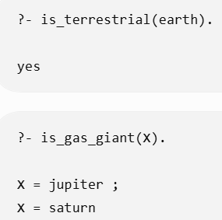

RESULT
Thus, the Prolog program was successfully executed to implement the planets database.

